H.T No
Regulations:
A15

Sreenidhi Institute of Science and Technology
(An Autonomous Institution)
Code No: 5FC09 Date: 13-Mar-2021(FN)

B.Tech III-Year I- Semester External Examination, March/April - 2021 (Supplementary)
Web Technologies (CSE and IT)

Time: 3 Hours Max.Marks:75

Note: a) No additional answer sheets will be provided.
b) All sub-parts of a question must be answered at one place only, otherwise it will not be valued.
c) Missing data can be assumed suitably.

ANSWER ANY 5 OUT OF 8 QUESTIONS. EACH QUESTION CARRIES 15 MARKS.

Bloom's Cognitive Levels of Learning (BCLL)

Remember | L1 | Apply | L3 | Evaluate | L5
Understand | L2 | Analyze | L4 | Create | L6

 |  |  | BCLL | CO(s) | Marks
1. | a) | Create a simple HTML page which demonstrates the use of three types of lists. | L6 | CO1 | [8M]
 | b) | Design the following Registration form using HTML  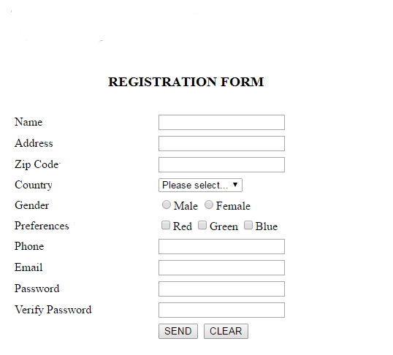 | L3 | CO1 | [7M]
2. | a) | Create a Web Page containing a form which has a single button and a text-field. When the button is clicked a dialog box should open which displays the contents of the text-field. | L6 | CO2 | [8M]
 | b) | Explain various control statements available with JavaScript with examples. | L2 | CO2 | [7M]
3. | a) | Illustrate the Document Type Definition (DTD) in XML and describe in detail Internal and External DTDs with examples. | L3 | CO3 | [8M]
 | b) | Write XML Schema for the following XML Document.  <?xml version="1.0"?>  <bookstore>  <book>  <title>WEB TECHNOLOGIES</title>  <author>Uttam.K.Roy </author>  <price>Rs.300 </price>  </book>  <book>  <title>DATA STRUCTURES</title>  <author>Gilberg </author>  <author>Forouzan</author>  <author>Prasad</author>  </book>  </bookstore> | L2 | CO3 | [7M]
4. | a) | Explore Servelet API. | L4 | CO4 | [8M]
 | b) | Construct a Servelet that greets the user by name. Accept the username through a HTML form. | L6 | CO4 | [7M]
5. | a) | Illustrate with examples the following directive elements.  (i) page directive  (ii) include directive  (iii) taglib directive | L3 | CO5 | [8M]
 | b) | Write a JSP to keep track number of users for a website and display a message “you are nth visitor Where n is number of user. | L2 | CO5 | [7M]
6. | a) | List and explain Different JDBC Drivers. | L2 | CO6 | [8M]
 | b) | Write a JSP/ Servelet program to insert the details of the users who register with the Online book store website by using registration form. | L2 | CO6 | [7M]
7. | a) | Illustrate the use of Inline, Internal and External styles in HTML document. | L3 | CO1 | [5M]
 | b) | List out built-in Objects in JavaScript. | L2 | CO2 | [5M]
 | c) | Can I replace HTML with XML? If yes/no justify your answer. | L2 | CO3 | [5M]
8. | a) | Discuss the use of cookies for developing web sites. | L2 | CO4 | [5M]
 | b) | What is JSP and why do we need it? | L1 | CO5 | [5M]
 | c) | What is the role of JDBC in web applications? | L1 | CO6 | [5M]

-- 00 -- 00 –

